# 

# PRESS RELEASE

Pressemitteilung • Communiqué de Presse • Comunicato Stampa

## Sundance integrates the new XilinxSDSoC development environmenton to its EMC2-Z7030 Zynq SoC-based PC/104 single board computer family

**The new EMC2-Z7030 is a stackable SBC with PC/104 OneBank interface and VITA57.1 FMC, controlled by a Zynq SoC and fully supported by the latest Xilinx SDSoC development environment**

**Chesham, UK – 17th February 2016.** Sundance Multiprocessor Technology Ltd., an established supplier and manufacturer of embedded modules for the PC/104-compatible format, has announced that it has integrated Xilinx’s new SDSoC development environment on to its EMC2-Z7030 single board computer (SBC). Sundance’s EMC2 range is a family of industrial-grade and deployment-ready SBC’s that feature a Xilinx Zynq SoC with integrated dual-core ARM-A9 CPUs coupled to 1Gb of DDR3 memory, four-lanes of PCI-Express and re-programmable logic with Kintex-7 FPGA technology. The EMC2 range is designed to the latest, yet long-established, PC/104 form factor of 90mm by 96mm, called OneBank.

The Xilinx SDSoC development environment has a full, system-optimizing C/C++ compiler that allows system and software engineers to take full advantage of the speed increase offered by running processing intensive algorithms on the Programmable Logic (PL) of the Zynq Z7030. The new development flow offers a familiar software development environment using an Eclipse-based GUI, programming in C/C++ and debugging from the ARM-A9 CPUs, called the Processing System (PS). SDSoC offers profiling, estimation and hardware/software event traces to help developers optimize the system performance while seamlessly generating the full Zynq SoC system with hardware accelerated IPs, data motion network and software BSPs.

“The combination of Sundance’s EMC2 boards and the Xilinx SDSoC development environment is another significant step forward for embedded systems design, enabling systems engineers to take advantage of the Zynq SoC’s combination of a popular ARM-A9 CPU and the flexible and fast I/O associated with FPGA technology,” said Flemming Christensen, Managing Director of Sundance Multiprocessor Technology Ltd. “While the Zynq SoC provides potential for implementing a powerful hardware accelerated system, it requires many disciplines across hardware, system and software engineers. The SDSoC offers the benefit of being able to gain performance by seamlessly moving algorithms into FPGA fabric from C/C++ applications, a game-changer for programmable embedded systems. Not only will the SDSoC environment significantly shorten the time-to-market for Zynq designs, it also opens the door to a new class of users who have been in traditional SoC domains developing primarily in software.”

Although the EMC2 concept, with an environment like SDSoC, is not entirely new, it is extremely cost effective. Sundance previously co-developed a similar board called HARP-2 in the early 1990’s that combined a 32-bit Inmos CPU with a Xilinx XC3195 FPGA. It was supported by Handle-C, initially developed by Oxford University and commercialized by Celoxica. The biggest problems with this solution, and hence its limited adoption, were its $100,000 per seat price tag and the requirement for detailed FPGA/VHDL knowledge. In comparison, Xilinx’s SDSoC can be easily used by any experienced C programmer and the EMC2-Z7030,with its dual-core ARM-A9 and Kintex-7 FPGA bundled with a commercial license for the Xilinx SDSoC environment, is priced at only $1,695, giving it the potential to make a significant impact in embedded systems design.

“The EMC2-Z7030,combined with the Xilinx SDSoC development environment, offers a total, industrial-grade and deployment-ready PC/104 embedded computing solution for varied applications that can benefit from the flexible concept of the Zynq SoC with integrated dual-core ARM-A9 and Kintex-7 FPGA fabric,” addedMarkJensen, Director of Corporate Software Strategy, Xilinx. “The addition of a VITA57.1 FMC-LPC makes it easy to migrate R&D efforts from Xilinx’s development bread-board to a fully rugged environment, be it air, land, sea or space. The SDSoC development environment and Sundance EMC2 board bundle is an ideal combination that is especially attractive for embedded systems design.”

The EMC2-Z7030benefits significantly from the PC/104 stackable concept that allows multiple EMC2 boards to be integrated into a multi-processing ARM/FPGA system, using PCI Express for inter-connection between each SBC. The concept is being developed by Sundance as part of $100 million industry-wide EU R&D project into [Embedded Multi-Core Systems for Mixed Criticality](http://www.artemis-emc2.eu/).

The EMC2-Z7030with a dual-core ARM-A9 and Kintex-7 FPGA, and bundled with a commercial license for the Xilinx SDSoC development environment is priced at $1,695. The 100+ price, without the SDSoC, is below $900. The EMC2- Z7030 and its variations are typically available on a lead-time of one to three weeks.

# # #

**About Sundance Multiprocessor Technology Ltd.**

Sundance designs, develops, manufactures, and markets internationally high performance signal processing and reconfigurable systems for original equipment manufacturers in embedded applications. Leveraging its multiprocessor expertise and experience, Sundance provides OEMs with modular systems as well as data acquisition, I/O, communication and interconnectivity products that are essential to multiprocessor systems where scalability and performance are essential. Sundance, founded in 1989 by the current directors, is a member of the Xilinx Alliance and MathWorks’ Connection programs. Sundance is also a member of the PC/104 Consortium, the focal point for the entire PC/104 industry including manufactures and OEMs. It provides a place for information on current specifications, product offerings, news, and events and a place to advance and develop specifications that are consistent and stable for long-term use. For more information about Sundance Multiprocessor Technology and its products, visit <http://www.sundance.com>.

All trademarks are recognised and are the property of their respective companies.

**Media contacts:**

Flemming Christensen, Managing Director, Sundance Microprocessor Technology

Tel: +44 (0)1494 793167.  Email: [flemming.c@sundance.com](mailto:flemming.c@sundance.com)

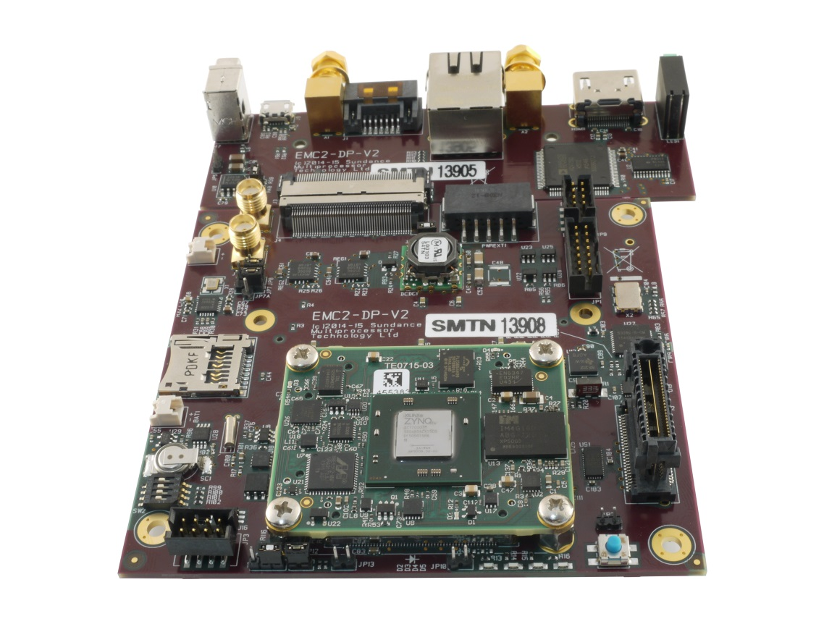

Figure 1: The EMC2 showing the Stackable PCIe/104 OneBank Connector and the Cable-less I/O board   
High-Resolution [download here](http://www.sundance.com/gallery/index.php?/category/11)

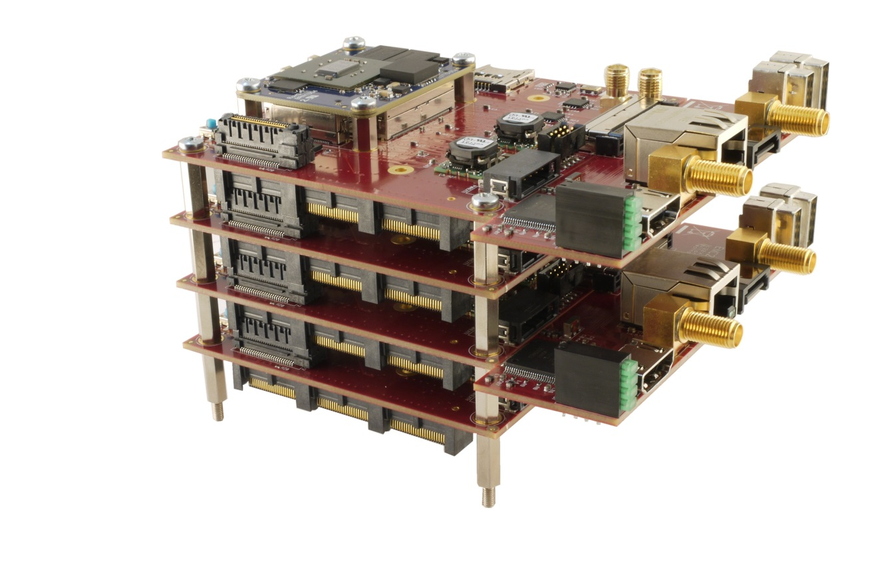

Figure 2: EMC2 stacked, using the PCI Express Lanes, to provide 8x ARM9 CPU Cores  
High-Resolution [download here](http://www.sundance.com/gallery/picture.php?/38/category/8)

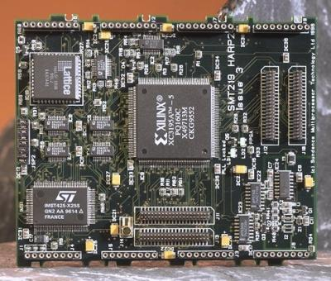

Figure 3: HARP-2 fitted onto a TRAM Module w. a 32-bit Inmos T425 CPU and a Xilinx XC3195 FPGA

Technical details [here](http://www.classiccmp.org/transputer/smt219.htm)

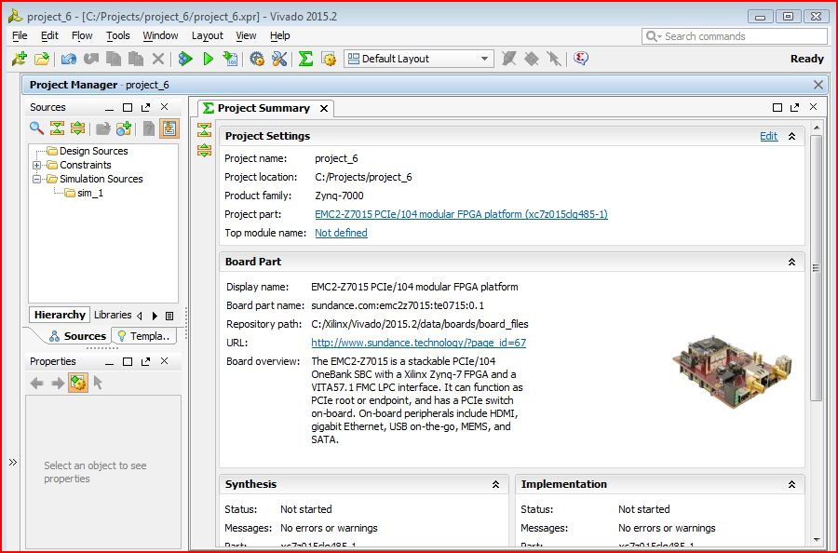

Figure 4: Screen-dump from the SDSoC integrated into Vivado2015.4  
High-Resolution download here

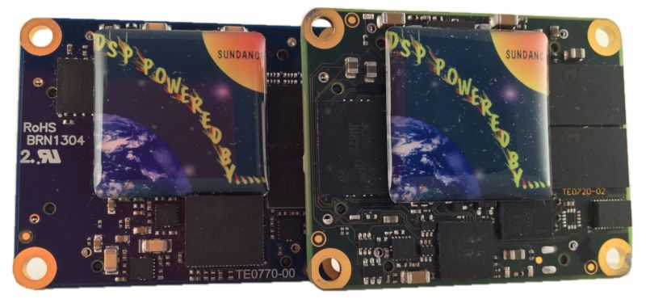

Figure 5: The 40mm x 50mm SoM Module for EMC2 with Xilinx Zynq SoC, Artix-7 or Kintex-7   
High-Resolution [download here](http://www.sundance.com/gallery/picture.php?/41/category/8)

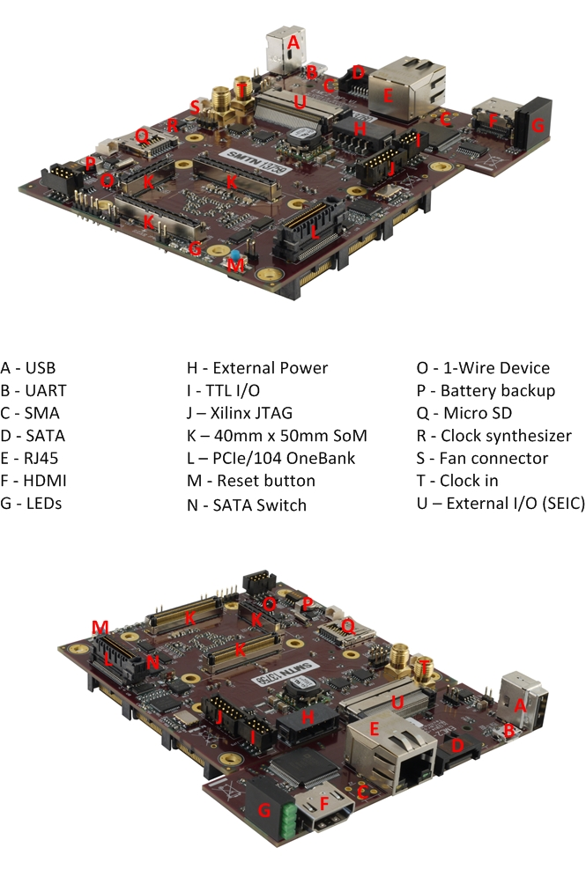 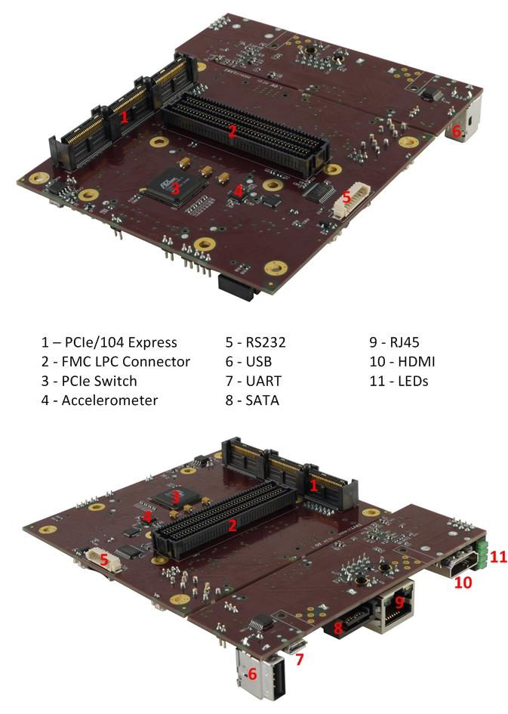

Figure 1: Location of EMC2-DP Interfaces   
High-Resolution [download here](http://www.sundance.com/gallery/picture.php?/37/category/8)