“GlobalTop unveils the Smallest Mediatek Multi-GNSS module in the world”

Tainan, Taiwan 01/09/2015
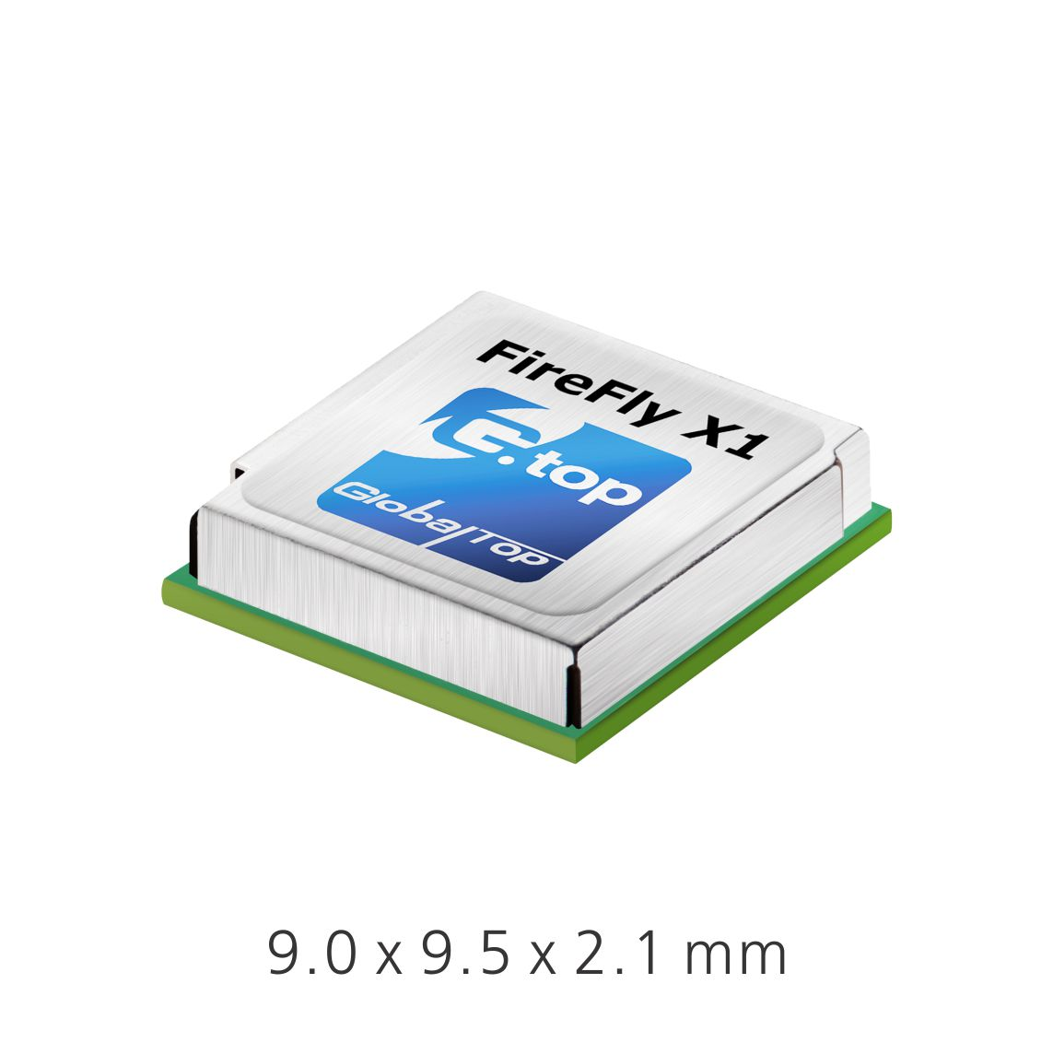GlobalTop Technology has launched FireFly X1, the smallest Mediatek-based Multi-GNSS module in the world. With an ultra-compact size of 9.0 x 9.5 x 2.1 mm, it’s one of the smallest Multi-GNSS modules in the industry.
“Compact size and low-power consumption will be the key USP’s for the next generation of M2M Devices. After a comprehensive market study, we found that small size was one of the most important factors for companies when it came to GNSS module selection; other key factors included power consumption, TTFF, positioning accuracy, additional interfaces as well as quality and longevity of the module. I am proud to say that FireFly X1 delivers perfectly on all these criteria”, said Sam Khan, Vice CEO of GlobalTop Technology. He added, “FireFly X1 is designed with sophisticated engineering and an entirely new set of ultra-compact quality components to reach this miniature size, while adding more features and interfaces at the same time. It uses the latest MT3333 engine with full support for GPS, QZSS, Glonass, Beidou and is also Galileo ready. “
Tracking of up to two constellations simultaneously, and relying on the latest Mediatek ﬁrmware, it can provide superior positioning accuracy of up to 1.8 m CEP. Enabling EASYTM (self-generated orbit prediction), AGPS (ephermis ﬁle injection), and SBAS further enhances position accuracy signiﬁcantly.
Unlike other compact GNSS modules, despite a smaller size, FireFly X1 incorporates a complete set of high-quality components, including TCXO, RTC Crystal, SMPS, SAW Filter and an additional LNA to provide the most reliable performance.
FireFly X1 combines miniature size with ﬂexible multi-interface connectivity options like SPI and I²C, that can simplify a user’s design, and is ideal for M2M devices relying on low-cost MCU’s that offer limited serial interfaces.
GlobalTop’s industry leading free customization service further expands the capability of FireFly X1 with unique features such as custom NMEA output sentence, distance calculation, geofencing, magnetic variation and last- position-retention, etc. Advance users can also customize the basic parameters of the module, including baud rate, update rate, internal logger settings, DGPS mode, 3D Fix, 1 PPS timing, and many more.
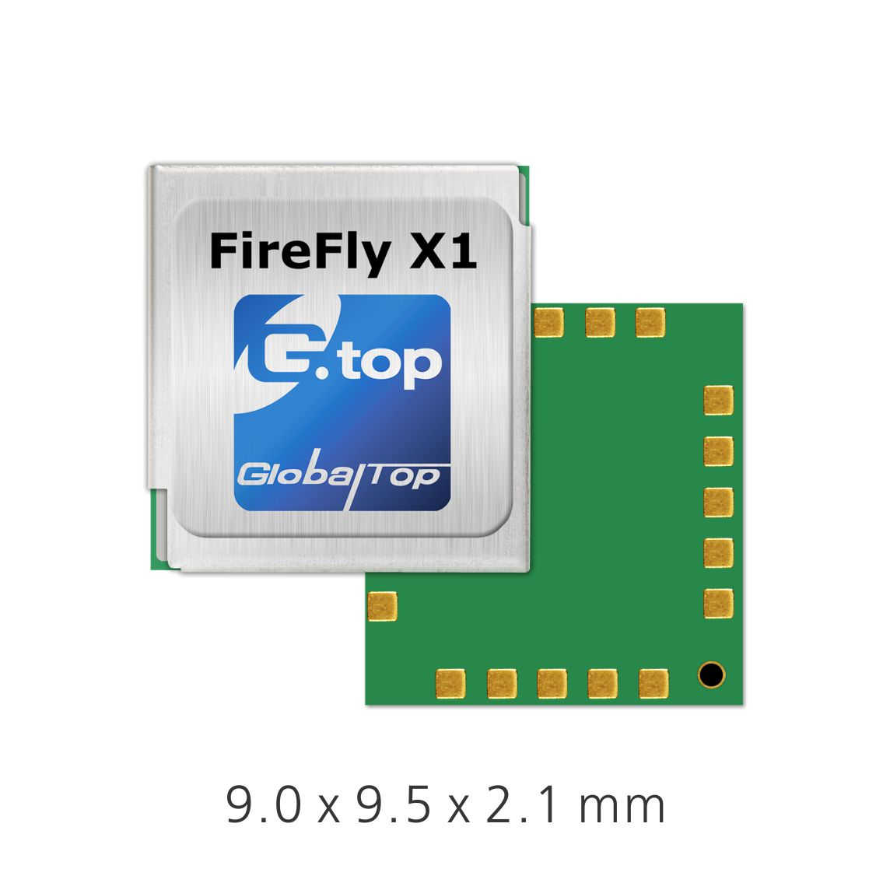All modules are produced at GlobalTop’s in-house ISO 9001:2008 certiﬁed manufacturing facility, with 100% unit testing and complete quality control, allowing for a consistent annual yield rate of 99.98%.

With the smallest size, outstanding RF sensitivity and performance, and best-in-class feature-set, the FireFly X1 is an unbeatable choice for any GNSS positioning application.
Samples and Evaluation Kits for FireFly X1 are now available. Please contact us or your local distributor for more information.

About GlobalTop
GlobalTop Technology is one of the leading suppliers of embedded positioning modules worldwide. With expert knowledge of wireless technologies and a comprehensive module portfolio, GlobalTop serves numerous M2M industrial market segments with highly innovative and customized solutions. Founded in 2006, GlobalTop is an award winning and strategic MTK partner. Based in the prestigious Tainan Science Park, Taiwan, its 4500 square meter manufacturing facility offers not only top-notch production with tight quality control but also the access to the best supply chain in Taiwan. For more information of the company, please visit: http://www.gtop-tech.com/

